[BCIS 5610 Enterprise Data Warehousing (Fall 2020)](https://unt.instructure.com/courses/32520)

Assignment -2

**Teachers Pay Teachers** is an online marketplace for teachers that connects teachers across the globe. This platform allows teachers to buy, sell, or share their educational materials with other teachers.

I have created a schema named **‘tpt_dim’.** I have created the dimensional model for this scenario. Below are the description of the Dimension tables and the Fact tables that I have created.

1. First, we have “User Dimension” and as per the scenario, I have constructed ‘Buyer_anannyac’ table and ‘Seller_anannyac’ table which are Aliases of User Dimension. The concept of Role Playing comes into picture here. As the ‘Sales_Fact_anannyac’ have two columns that get the respective data from these two alias tables, hence the concept of role playing can be made more effective here.

The User Dimension (Buyer_anannyac) also serves a conformed dimension as both the Sales Fact table and Review Fact table make use of User Dimension as one of their dimensions respectively.

1. Then I **have Product Dimension** (Productdim_anannyac) that contains details about the various products. This is a conformed dimension as both the Sales Fact table and Review Fact table make use of Product dimension as one of their dimensions, respectively.
2. The **Transaction Dimension** contains the various details about the transactions that are taking place.
3. Lastly, we have the **Time Dimension** and as per the scenario, here Time Dimension is a conformed dimension. The ‘purchase_Date_anannyac’ table which is part of Sales Fact table and ‘review_date_anannyac’ table which is part of Review Fact table are both dealing with Time Dimension.

In the Sales Fact tables, we also have ‘Quantity’ and ‘Sale_Amount’ which are the facts that are measures. At the end, we also have ‘Order No.’ and ‘Timestamp’ which are present as Degenerate dimensions in the Sales Fact table.

In the Review Fact table, we are not capturing any fact that are measures. But since we are capturing the relationship between multiple entities, so it is a Fact-less fact table. Here other than Buyer_key, Review_date_key and Product_key, all other columns including the ‘Timestamp and Order No.’ are treated as Degenerate dimensions.

Please find the snapshots of MySQL database named ‘tpt_dim’ that I have created and all the dimension tables and the Fact tables that are inside this database. The names of all the tables are as follows:

1. buyer_anannyac
2. seller_anannyac
3. productdim_anannyac
4. purchase_date_anannyac
5. transactiondim_anannyac
6. review_date_anannyac
7. sales_fact_anannyac
8. review_fact_anannyac

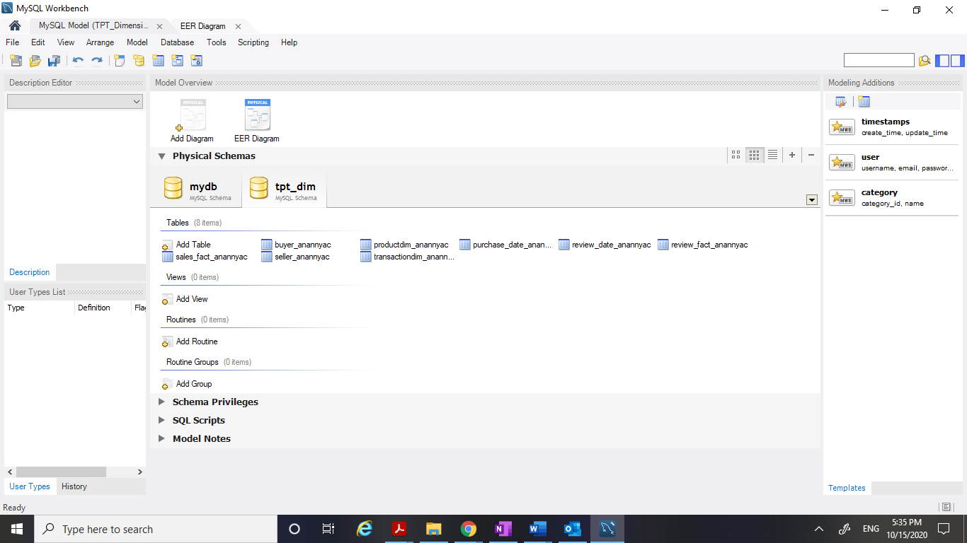

1. **Buyer_anannyac**

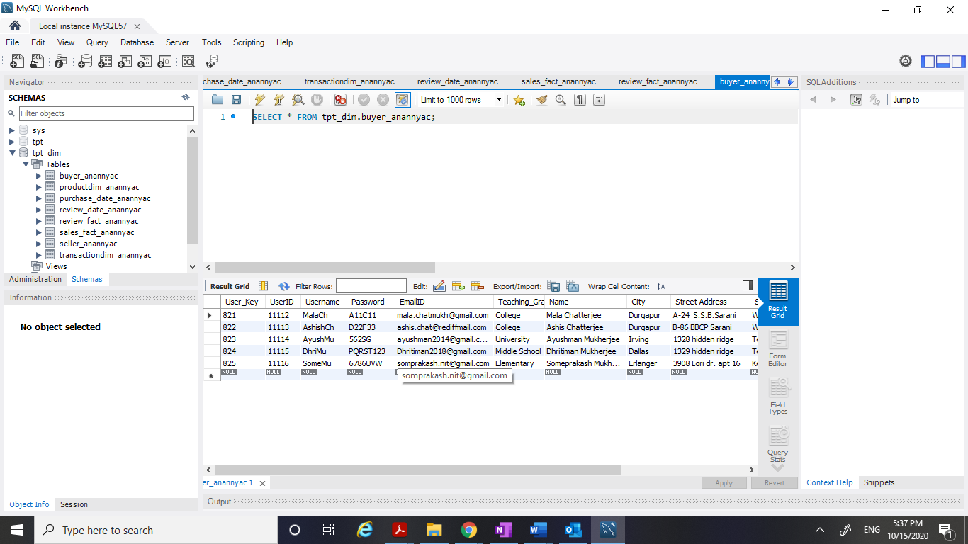

1. **Seller_anannyac**

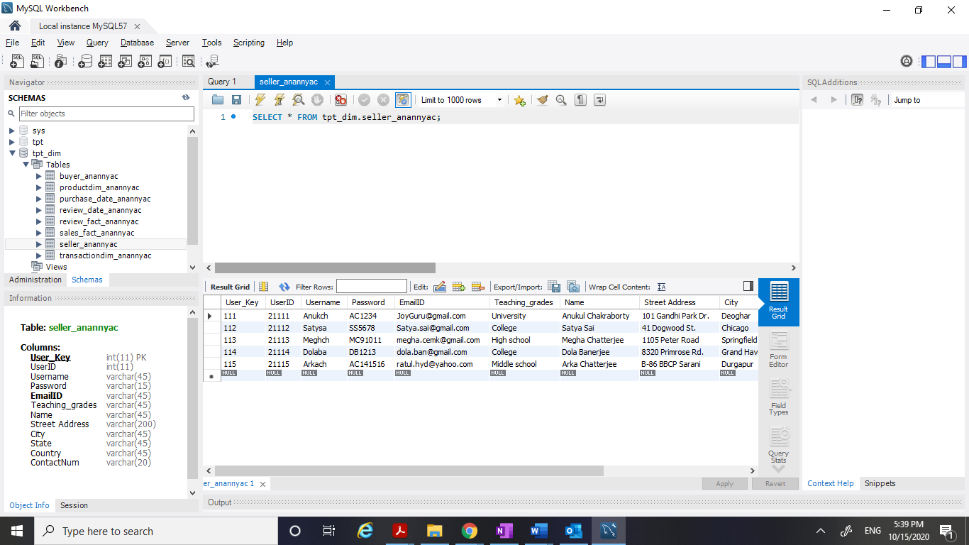

1. **Productdim_anannyac**

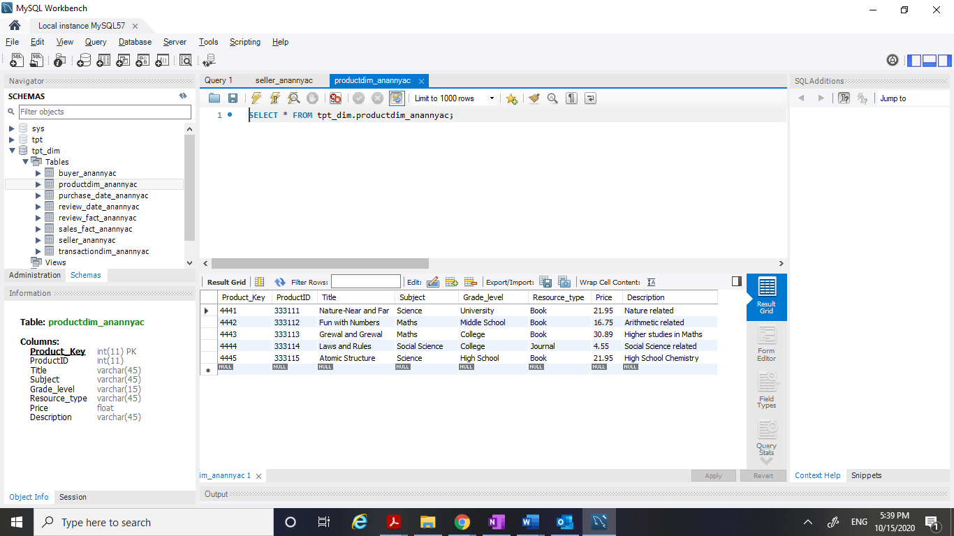

1. **Purchase_date_anannyac**

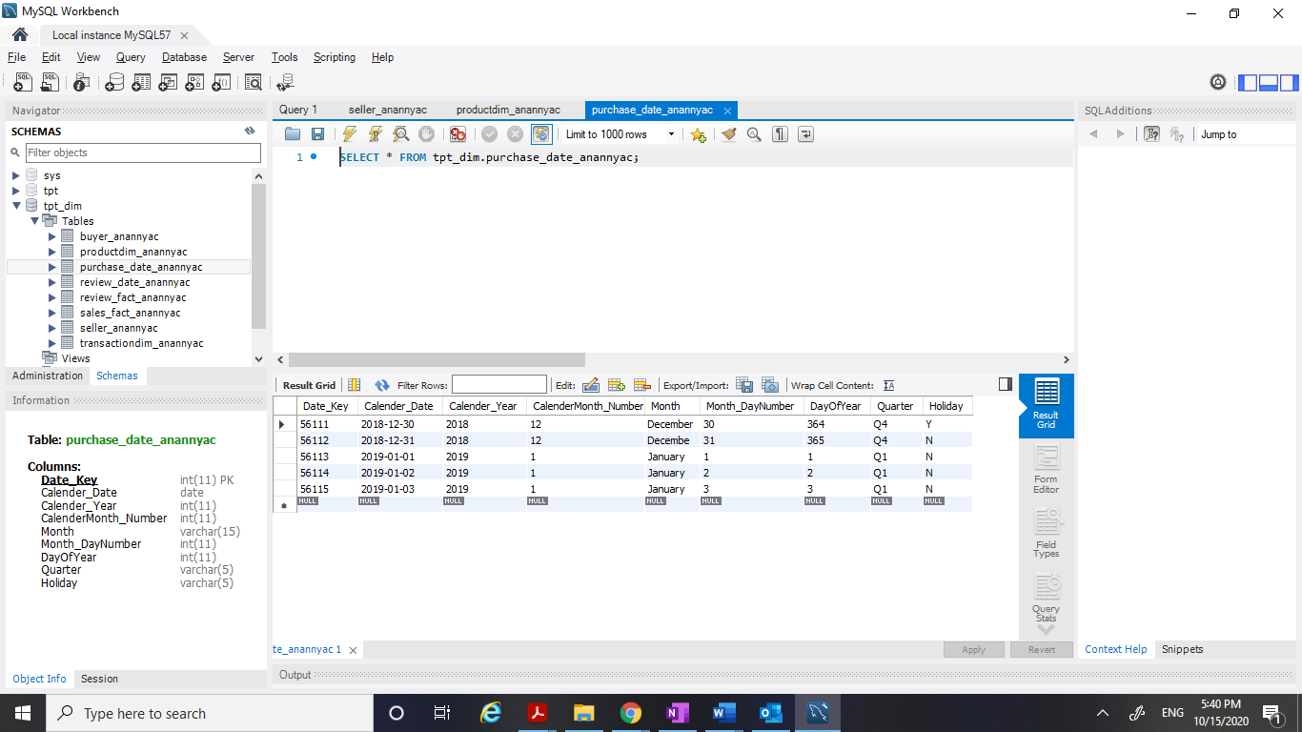

1. **transactiondim_anannyac**

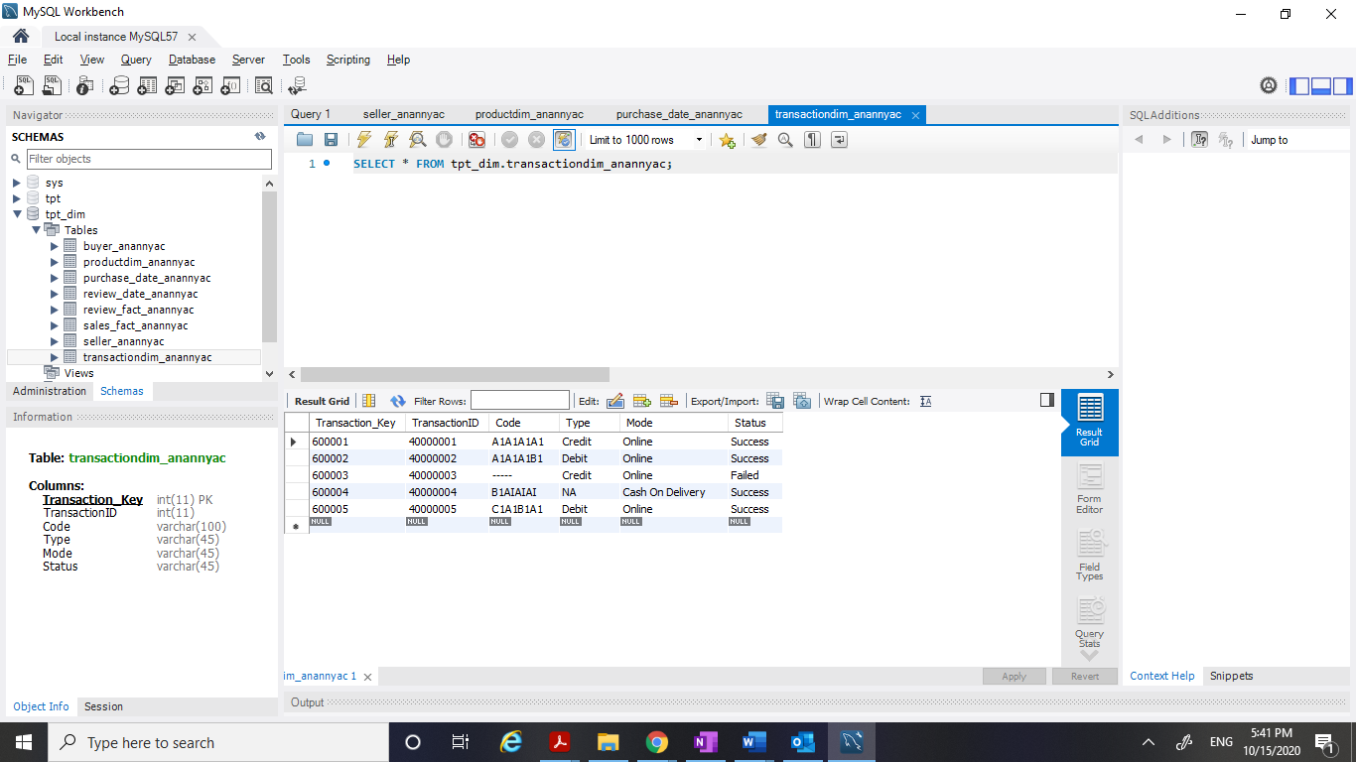

1. **review_date_anannyac**

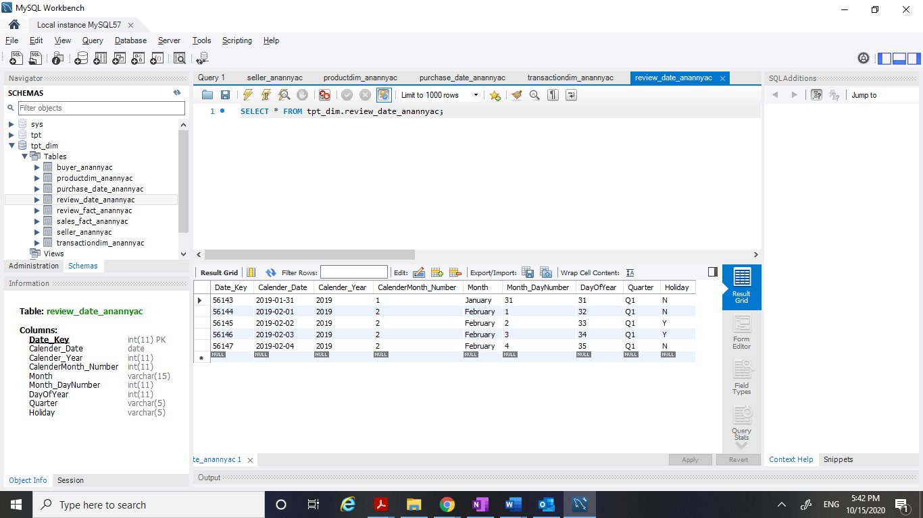

1. **sales_fact_anannyac**

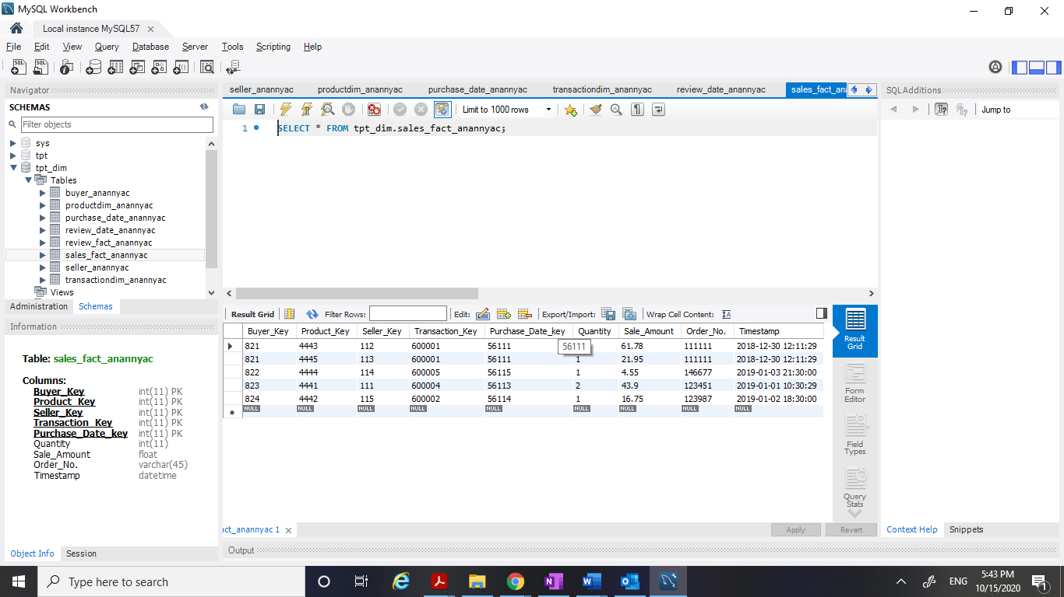

1. **review_fact_anannyac**

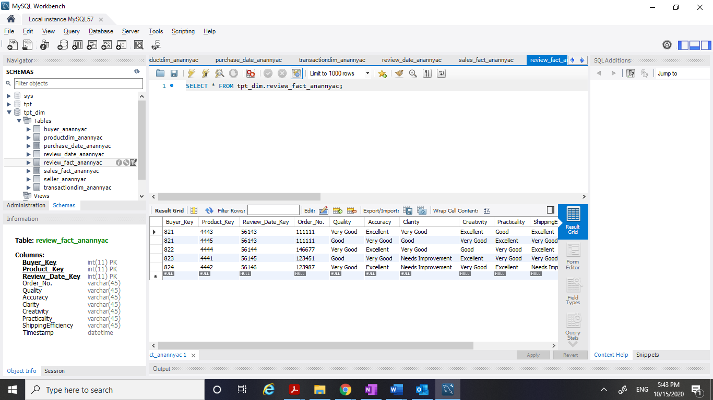

**Relationships between the Fact table and the Dimension table:**

There is always 1:M relationship between Dimension table and Fact table.

Each instance of the Fact table will point to one and only one instance of each of the Dimension tables.

As already mentioned previously, there are two fact tables.

1. Sales Fact table (sales_fact_anannyac)
2. Review Fact table (review_fact_anannyac)

-------------------------------------------XXXXXXXXXX---------------------------------------------